Reading comprehension exercises
A Story about Medusa and Athena
Once upon a time there lived a beautiful girl named Medusa. Medusa lived in the city of Athens, in Greece -- and although there were many pretty girls in the city, Medusa was considered the most lovely.
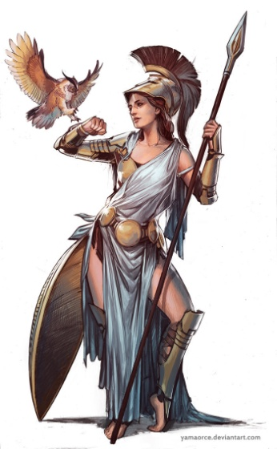
Medusa was very proud of her beauty and thought or spoke only of herself. Each day she boasted of how pretty she was. Medusa even boasted that she was prettier than Athena, goddess of wisdom, who watched over Athens.
Athena decided to punish Medusa for her pride. “Foolish girl,” Athena said angrily, “You think you are prettier than I am! I doubt it to be true, but even if it were -- there is more to life than beauty alone. While others work and play and learn, you only boast and admire yourself.”
And with those words Medusa’s face changed to that of a hideous monster. Her hair twisted and thickened into horrible snakes that hissed and fought each other atop her head.
“Medusa, your face is now so terrible that the mere sight of it will turn a man to stone,” said the goddess, “Even you, Medusa, will turn into a rock if you see your face.” And with that, Athena sent Medusa with her hair of snakes to live with the blind monsters -- the Gorgon sisters -- at the end of the Earth.
1. Say if the sentence is true or false.
- Medusa was a very pretty girl. ___________________________________________
- Medusa respected Athena. ______________________________________________
- Athena decided to punish Medusa for her beauty. ____________________________
- Athena turned Medusa into a hideous monster._______________________________
- Medusa’s look turned people to ice. ________________________________________
- Medusa stayed in Athens. ________________________________________________
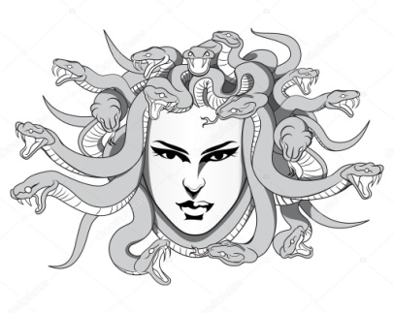
2. Complete the phrase.
- Medusa lived in the city of ______________
- Athena was a goddess of _______________________.
- Medusa’s hair turned into __________________.
- Athena sent Medusa to live at the ends of the earth with ____________________________.
3. Answer the questions.
1. Which character traits given below are for Medusa and which are for Athena: boasting, wise, cruel, proud, idle, fair, careless? Explain your choices.
2. Do you think the punishment for Medusa fair? Give your reasons.
3. Do you agree with Athena’s words “There is more to life than beauty alone”? Give your reasons.

